PROBLEM 1:

* This Java program is designed to rotate the elements of an integer array to the right by 2 bits.
* The main method initializes an array original Array with values {10, 11, 12, 13} and then prints the original array along with its 32-bit binary representation for each element.
* After that, the rotateRightBy2Bits method is called to perform the right rotation on each element of the array.
* Finally, the program prints the rotated array along with its updated 32-bit binary representation.

Here's a breakdown of the key components of the code:

i) **rotateRightBy2Bits method:**

This method takes an integer array s as an argument.

It uses a loop to iterate through each element of the array.

For each element, it performs a right rotation by 2 bits by keeping an element in an identifier ‘temp’. Then, right shift by 2 bits and left shift by 30 bits is being performed with ‘temp’ variable which is then stored in an identifier ‘p’ and ‘k’ respectively.

Lastly; the element of the array is being updated by the value obtained by the bitwise OR operation performed between ‘k’ and ‘p’ .

ii) **printArray method:**

This method takes an integer array a as an argument. It uses an enhanced for loop to iterate through the elements of the array and prints them separated by spaces.

**iii) printBinaryArray method:**

This method also takes an integer array a as an argument.

It uses an enhanced for loop to iterate through the elements of the array.

For each element, it converts the integer to its 32-bit binary representation using Integer.toBinaryString.

It ensures that the binary representation is displayed with leading zeros to make it 32 bits long using String.format.

The binary representation is then printed, separated by spaces.

iv) **main method:**

It initializes an array originalArray with values {10, 11, 12, 13}.

Prints the original array and its 32-bit binary representation.

Calls the ‘rotateRightBy2Bits’ method to perform the right rotation on each element of the array.

Prints the rotated array and its updated 32-bit binary representation.

The rotation is achieved using the Integer.rotateRight method, which takes an integer value and the number of positions to rotate to the right. In this case, each element of the array is rotated by 2 bits to the right.

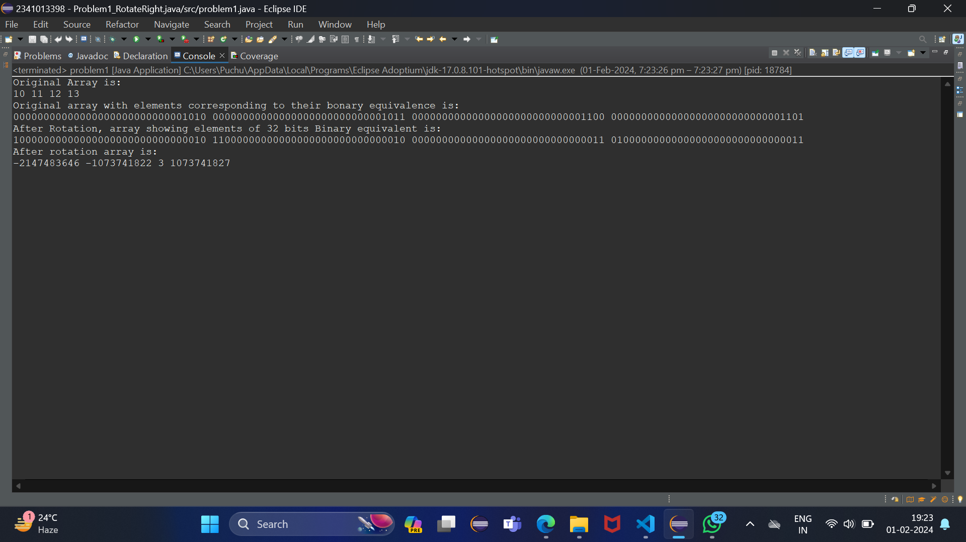OUTPUT: